<!DOCTYPE html>

<html>

<head>

<title>ECO MART</title>

< !-- code for font awesome cdn -->

<link rel="stylesheet" href="https://cdnjs.cloudflare.com/ajax/libs/font-awesome/4.7.0/font-awesome.min.css">

<!--code for font awesome cdn -->

<!-- code for linking css file -->

<link rel="stylesheet" type="text/css" href="css/style.css">

<!-- code for linking css file -->

<link rel="stylesheet" href="https://unpkg.com/swiper@7/swiper-bundle.min.css">

<meta name="viewport" content="width=device-width, initial-scale=1.0">

</head>

<body>

<!-- header section-->

<header class="header">

<a href="#" class="logo"><i class="fa fa-shopping-basket"></i> ECO MART</a>

<nav class="navbar">

<a herf="#home">Home</a>

<a href="#About us">About us</a>

<a herf="#features">features</a>

<a herf="#products">products</a>

<a herf="#categories">categories</a>

<a herf="#contact">contact us</a>

</nav>

<div class="icons">

<div class="fa fa-bars" id="menu-btn"></div>

<div class="fa fa-search" id="search-btn"></div>

<div class="fa fa-shopping-cart" id="shopping-cart-btn"></div>

<div class="fa fa-user" id="login-btn"></div></div>

</header>

<!--header section-->

<!--banner section-->

<section class="home" id="home">

<div class ="content"><h1>ECO MART</h1>

<h3>Fresh And <span> Organic </span> Product For You</h3>

<h4>Welcome to ECO MART - Your Daily Dose Of Freshness!</h4>

<h5>#free Delivery</h5>

<a href ="#" class="btn">Shop Now</a>

</div>

</section>

<!--banner section-->

@import url('https://fonts.googleapis.com/css2?family=Poppins:ital,wght@0,400;0,500;1,300&display=swap');

:root

{

--green:green;

--black:#130f40;

--light-color:#555;

--box-shadow:0 .1rem 1rem rgba(0,0,0.1);

--broder:2rem solid rgba(0,0,0.1);

--outline:.1rem solid rgba(0,0,0.1);

}

* { font-family: 'Poppins', sans-serif;

margin:0;

margin: 0;

box-sizing: border-box;

outline:none;

broder:none;

text-decoration:none;

text-transform:capitalize;

transition:all .2s linear;

}

html

{

font-size: 80%;

overflow-x: hidden;

scrll-behavior:smooth;

scroll-padding-top:7rem;

}

body

{

background: #eee;

}

.btn

{

border:.1rem solid var(--black) ;

margin-top:1rem;

display:inline-block;

padding:.4rem 2rem;

font-size:1.2rem;

border-radius:.4rem;

color:var(--black);

cursor:pointer;

background:none;

}

.header {

border:0px solid;

position: fixed;

top:0;

left:0;

right:0;

z-index: 1000;

display:flex;

align-items: center;

justify-content:space-between ;

padding:0.5rem 7% ;

background: #fff;

box-shadow: var(--box-shadow);

}

.header .logo

{

font-size:2.5rem;

font-weight: bolder;

border-spacing: 1rem;

}

.header .logo i

{

color:var(--green);

}

.header .navbar a

{

font-size:2rem ;

margin:0 1rem;

color: var(--black);

}

.header .navbar a:hover

{

color: var(--green);

}

.header .icons div

{

broder:0px solid;

height: 2.5rem;

width:2.5rem;

line-height:2.5rem ;

border-radius:.5rem;

background: #eee;

color:var(--black);

font-size: 1.5rem;

margin-right:.3rem;

text-align:center;

cursor:pointer;

}

.header .icons div:hover

{ background:var(--green) ;

color:white;

}

/\*css code for banner\*/

section

{ padding: 2rem 9%;

}

.heading

{

text-align: center;

padding:2rem 0;

padding-bottom: 3rem;

font-size: 3.2rem;

color:var(--black) ;

}

.heading span

{

background: var(--green);

color: #fff;

display:inline-block ;

padding: .5rem 3rem;

clip-path: polygon(100% 0, 93% 50%, 100% 99%, 0% 110% ,7% 50%,0% 0%);

}

.home

{

border: 0px solid;

display: flex;

justify-content: center;

background: url(../image/image/banner-img.jpg) no-repeat;

background-position:center;

background-size:cover ;

padding-top:10rem;

padding-bottom:10rem;

}

.home .content

{

border: 0px solid;

text-align: center;

width: 60rem;

}

.home .content h3

{

color: var(--black);

font-size: 3rem;

padding: .2rem;

}

.home .content h3 span

{

color: var(--green);}

.home .content h1

{

color: var(--black);

font-size: 2rem;

font-style: inherits;

}

.home .content h4

{

color: var(--black);

font-size: 1.5rem;

padding: .2rem;

}

.home .content h5

{

color: var(--black);

font-size: 1.7rem;

padding: .2rem;

}

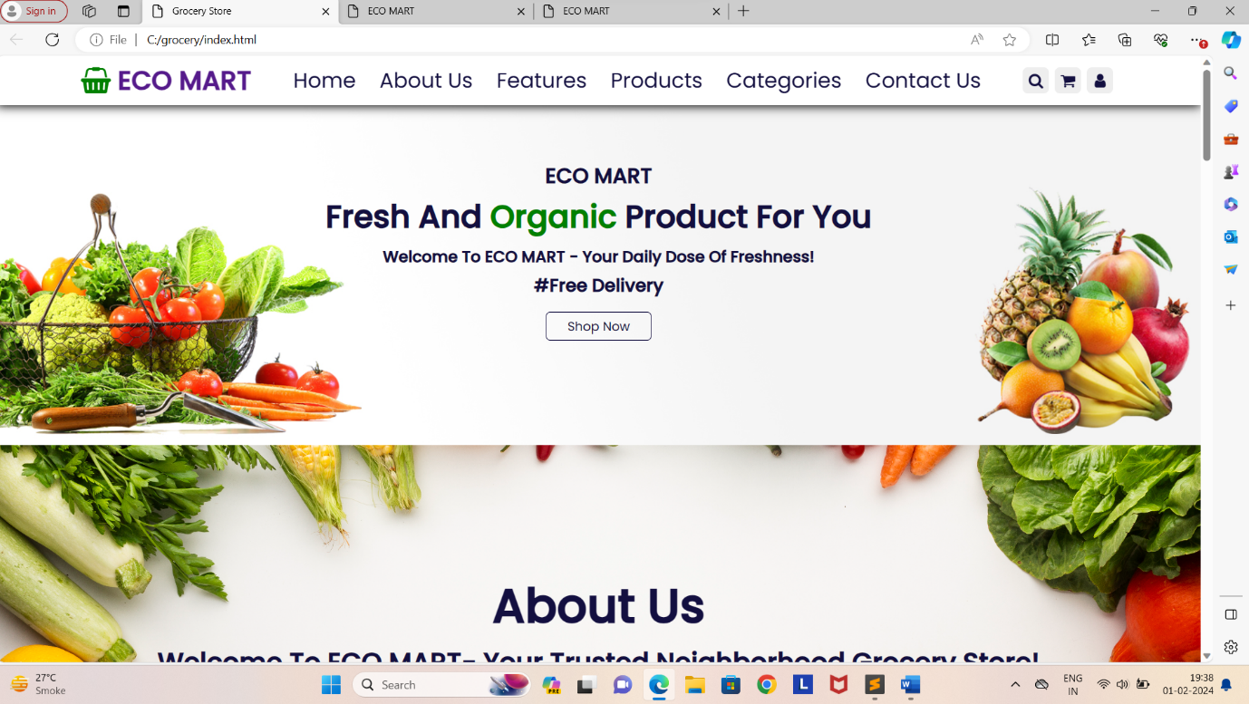

<!--our about us section-->

<section class="about" id="about">

<div class="heading"><h1>About us</h1>

<pre><h3>Welcome to ECO MART- Your Trusted Neighborhood Grocery Store!</h3><p> At ECO MART, we believe that shopping for groceries should be a seamless

and enjoyable experience.Our journey began with a simple vision - to provide

our community with access to fresh, high-quality products while

fostering a sense of convenience and trust.</p></pre>

</div>

</section>

<!--our about us section-->

/\*css code for about us\*/

section

{

padding: 1.5rem;

}

.heading

{

text-align: center;

padding:2rem 0;

padding-bottom: 3rem;

font-size: 3rem;

color:var(--black);

}

.about

{

border: 0px solid;

display: flex;

justify-content: center;

background: url(../image/image/colorful-veggies-frame-with-copy-space.jpg) no-repeat;

background-position:center;

background-size:cover;

padding-top:10rem;

padding-bottom:10rem;

}

.about .heading .h1

{

border: 0px solid;

text-align: center;

width:50rem;

padding: 1rem 0;

}

.about .heading h3

{ color: var(--black);

font-size:2.5rem;

padding: .1rem;

}

.about .heading p

{ color: var(--black);

font-size:2rem;

padding: 2rem 2rem;

text-align: center;}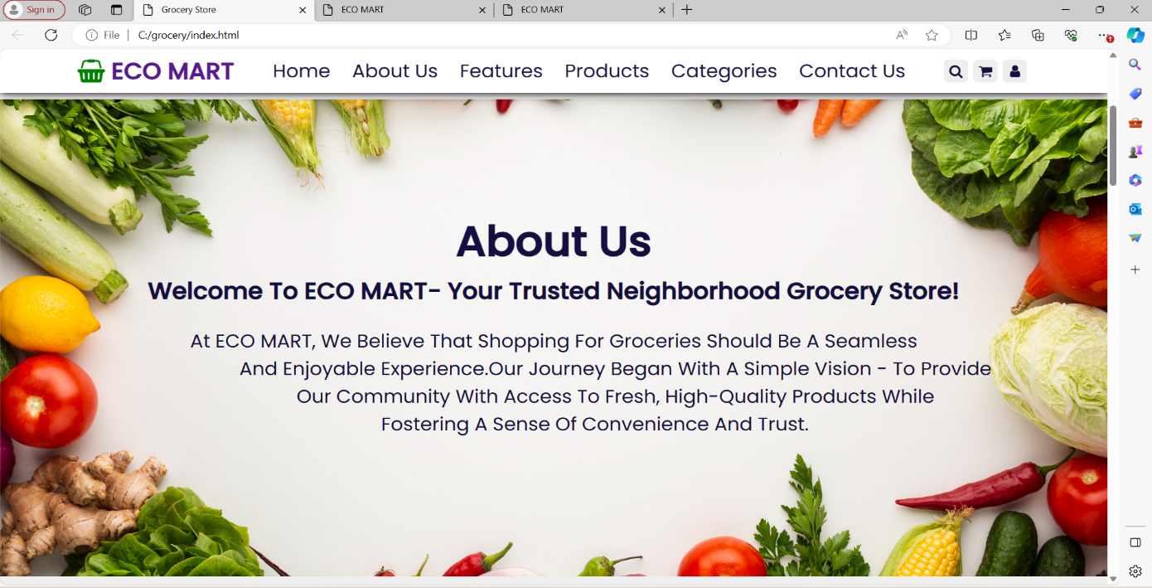

<!-- our features section-->

<section class ="features" id="features">

<h1 class="heading"> our <span> Features </span></h1>

<div class="box-container">

<div class="box">

<img src="image/image/feature-img-1.png"></img>

<h3>fresh and organic</h3>

<p>Our veggies are super fresh and totally organic.

That means no harmful stuff-just Pure,Natural Goodness.</p>

<a href="#" class="btn">Read more</a>

</div><div class="box">

<img src="image/image/feature-img-2.png"></img>

<h3>Free Delivery</h3>

<p>We're delivery your fresh veggines for free!No extra charge-Just tasty,Healthy vegetables right at your door </p>

<a href="#" class="btn">Read more</a></div>

<div class="box">

<img src="image/image/feature-img-3.png"></img>

<h3>Easy Payments</h3>

<p>Shopping for veggies is a breeze with our easy payment options.No stress,just easy ways to pay</p>

<a href="#" class="btn">Read more</a>

</div></div>

</section>

<!-- our features section-->

/\*features\*/

.features .box-container

{ border: 0px solid;

display: grid;

grid-template-columns: repeat(auto-fit, minmax(30rem, 1fr));

gap:1.5rem;

}

.features .box-container .box

{

border: 0px solid red;

padding: 5rem 3rem;

background: #fff;

outline: var(--outline);

outline-offset: -1rem;

text-align: center;

border: var(--box-shadow);

transition:.2s linear;

}

.features .box-container .box:hover

{

box-shadow: 1px 1px 10px 4px var(--green);

}

.features .box-container .box h3

{

font-size:2rem;

line-height: 1.5;

color: var(--black);}

.features .box-container .box p

{

font-size:1.3rem;

line-height:1.3;

color: var(--light-color);

padding:.5rem 0;

}

/\*features\*/

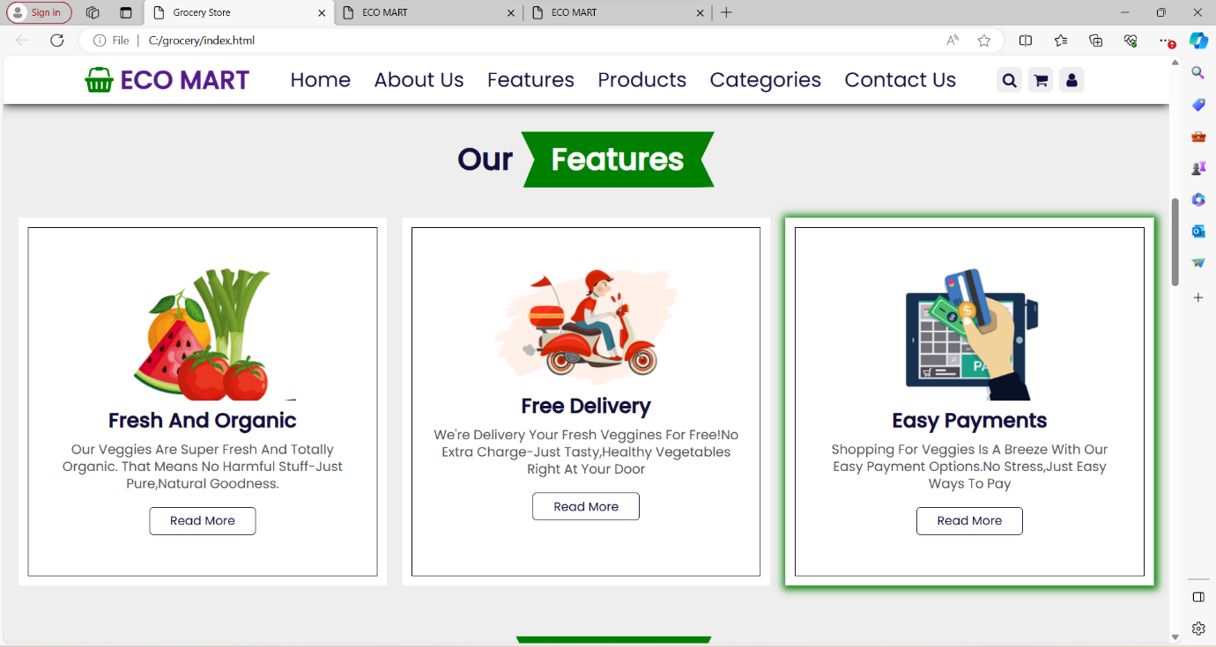

<!-- our Categories section-->

<section class="categories" id="categories" >

<h1 class="heading">product<span>categories</span></h1>

<div class="box-container">

<div class="box">

<img src="image/image/cat-1.png">

<h3>vegetables</h3>

<p>Upto 50% off</p>

<a href="#" class="btn">Shop Now</a>

</div><div class="box">

<img src="image/image/cat-2.png">

<h3>Fresh Fruits</h3>

<p>Upto 30% off</p>

<a href="#" class="btn">Shop Now</a>

</div>

<div class="box">

<img src="image/image/cat-3.png">

<h3>Dairy Products</h3>

<p>Upto 20% off</p>

<a href="#" class="btn">Shop Now</a>

</div>

<div class="box">

<img src="image/image/cat-4.png">

<h3>Fresh Meat</h3>

<p>Upto 10% off</p>

<a href="#" class="btn">Shop Now</a>

</div>

</div>

</section>

<!-- our categories section-->

/\*categories\*/

.categories .box-container

{border: 0px solid;

display: grid;

grid-template-columns: repeat(auto-fit, minmax(22rem, 1fr));gap:1.5rem;}

.categories .box-container .box

{

padding: 3rem 0;

background: #fff;

border-radius: .5rem;

border: var(--box-shadow);

transition: .2s linear;

outline:var(--outline);

outline-offset: -1rem;

text-align: center;

}.categories .box-container .box:hover

{

box-shadow: 1px 1px 10px 4px var(--green);

}

.categories .box-container .box img

{

margin: 1rem 1rem;

height: 15rem;

}

.categories .box-container .box h3

{font-size: 2rem;

color: var(--black);

line-height: 1.8;

}

.categories .box-container .box p

{

font-size: 1.7rem;

color: var(--light-color);

line-height: 1.8;

padding: .5rem 0;

}

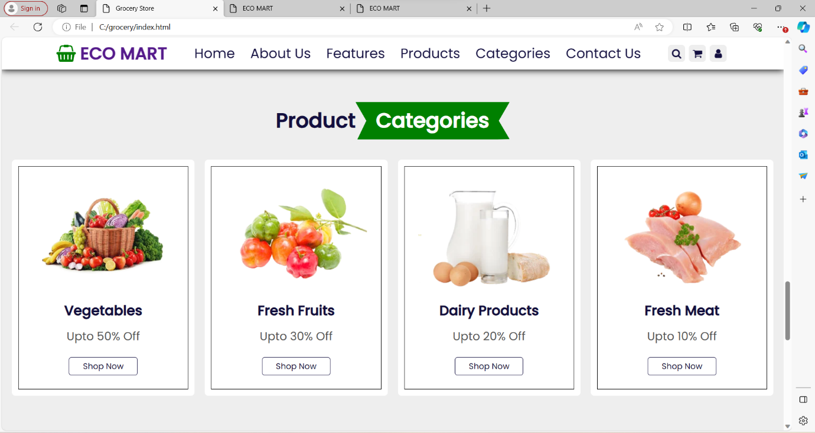

<!--our contact section-->

<section class="contact" id="contact">

<h1 class="heading">Contact Us</h1>

<div class="carry">

<div class="Address">

<a href="#" class="address"><i class="fa fa-location-arrow"></i>Our Office Address</a>

<pre><p>Show No 1, Sunshine Building,Plot No 10,

Near SBI Bank,Vashi Sector 10,Navi Mumbai,

Maharashtra 400700</p></pre>

</div>

<div class="General">

<a href="#" class="General"><i class="fa fa-envelope"></i>General Enquiries</a>

<pre><p>ABC@gmail.com

XYZ@gmail.com</p></pre>

</div>

<div class="Call Us">

<a href="#" class="Call"><i class="fa fa-phone"></i>Call Us</a>

<pre><p>+91-9988776655

+91-5524567895</p></pre>

</div>

<div class="timing">

<a href="#" class="timing"><i class="fa fa-globe"></i>Our Timing</a>

<pre><p>MON - WED : 9:00 AM - 10:00 PM

THR - SUN :8:00 AM -12:00 PM</p></pre>

</div>

</div>

</section>

<!--our contact section-->

.contact h1

{font-size:4.2rem;

}

.contact .Address i

{font-size:2rem;

font-weight: bolder;

border-spacing: 1rem;

padding:1rem;

}

.contact .Address a

{font-size: 2rem;

font-weight: bolder;}

.contact .Address p

{font-size: 1.3rem;

padding: .1rem 1rem;}

.contact .General i

{font-size:2rem;

font-weight: bolder;

border-spacing: 1rem;

padding: 1rem;}

.contact .General a

{font-size: 2rem;

font-weight: bolder;}

.contact .General p

{font-size: 1.3rem;

padding: .1rem 1rem;}

.contact .Call i

{ font-size:2rem;

font-weight: bolder;

border-spacing: 1rem;

padding: 1rem;

}

.contact .Call a

{font-size:2rem;

font-weight: bolder;}

.contact .Call p

{

font-size: 1.3rem;

padding: .1rem 1rem;

}

.contact .timing i

{font-size:2rem;

font-weight: bolder;

border-spacing: 1rem;

padding: 1rem;}

.contact .timing a

{ font-size:2rem;

font-weight: bolder;

}

.contact .timing p

{ font-size: 1.3rem;

padding: .1rem 1rem;

}

.contact .carry

{padding: 1rem 11rem;

background: url(../image/image/eco.png) no-repeat;

background-size:60rem ;

background-position:right;

}

.contact .day img

{ height: 28rem;

padding-left:55rem ;

}

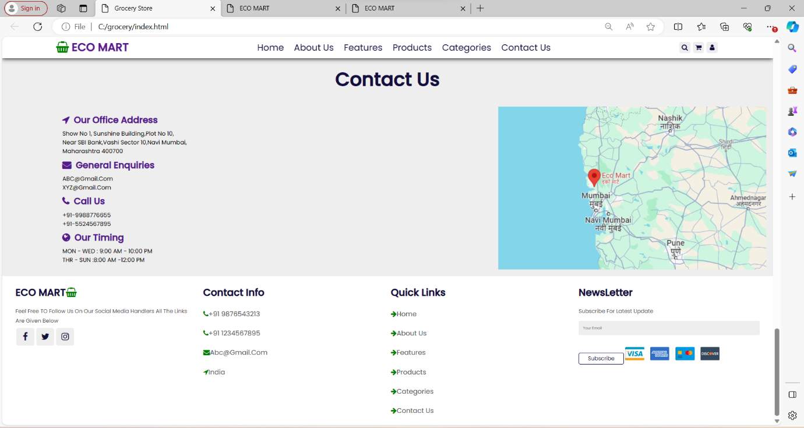

<!--our footer section-->

<section class="footer">

<div class="box-container">

<div class="box"><h3>ECO MART<i class="fa fa-shopping-basket"></i></h3>

<p>Feel Free TO Follow Us On Our Social Media Handlers All The Links Are Given Below</p>

<div class="share">

<a href="#" class="fa fa-facebook"></a>

<a href="#" class="fa fa-twitter"></a>

<a href="#" class="fa fa-instagram"></a>

</div>

</div>

<div class="box">

<h3>Contact Info</h3>

<a href="#" class="links"><i class="fa fa-phone"></i>+91 9876543213</a>

<a href="#" class="links"><i class="fa fa-phone"></i>+91 1234567895</a>

<a href="#" class="links"><i class="fa fa-envelope"></i>abc@gmail.com</a>

<a href="#" class="links"><i class="fa fa-location-arrow"></i>india</a>

</div>

<div class="box"><h3>Quick Links</h3>

<a href="#" class="links"><i class="fa fa-arrow-right"></i>Home</a>

<a href="#" class="links"><i class="fa fa-arrow-right"></i>About Us</a>

<a href="#" class="links"><i class="fa fa-arrow-right"></i>Features</a>

<a href="#" class="links"><i class="fa fa-arrow-right"></i>Products</a>

<a href="#" class="links"><i class="fa fa-arrow-right"></i>Categories</a>

<a href="#" class="links"><i class="fa fa-arrow-right"></i>Contact Us</a>

</div>

<div class="box">

<h3>NewsLetter</h3>

<p>Subscribe For Latest Update</p>

<input type="email" placeholder="Your Email" class="email">

<input type="submit" value="subscribe" class="btn"> <img src="image/image/payment.png" class="payment-img"></img> </div></div>

</section>

<!--our footer section-->

/\*footer\*/

.footer

{background: #fff;

padding: 1rem 3rem;}

.footer .box-container

{border: 0px solid;

display: grid;

grid-template-columns: repeat(auto-fit, minmax(26rem, 1fr));

gap: 1.5rem;}

.footer .box-container .box h3

{font-size: 2.2rem;

color: var(--black);

padding: 1rem 0;}

.footer .box-container .box h3 i

{color: var(--green);}

.footer .box-container .box .links

{ display:block;

font-size:1.5rem;

color: var(--light-color);

padding: 1rem 0; }

.footer .box-container .box .links i

{ color: var(--green);

padding-right:.5rem 0;}

.footer .box-container .box .links:hover i

{ padding-right:2rem; }

.footer .box-container .box p

{ line-height: 1.8;

font-size: 1.2rem;

color: var(--light-color);

padding: .5rem 0; }

.footer .box-container .box .share a

{ border: 0px solid;

height: 4rem;

width: 4rem;

line-height: 4rem;

border-radius: .5rem;

font-size: 2rem;

color: var(--black);

margin-left:.2rem;

background: #eee;

text-align: center;}

.footer .box-container .box .share a:hover

{ background: var(--green);

color: #fff;

}

.footer .box-container .box .email

{ width: 100%;

margin: .6rem 0;

padding: 1rem;

background:#eee;

font-size:.8rem ;

border-radius: .3rem;

color: var(--black);

text-transform: none;

border: 0px solid;}

.footer .box-container .box .payment-img

{ margin-top: 2rem;

height: 3rem;

}/\*footer\*/

</body>

</html>